**DSA Lab Task 01**

**Syed Muhammad Saleh**

**ID: 232044**

**Task 1:**

*// Store the marks of 5 students, display them, and calculate the average of the marks.*

#include <iostream>

using namespace std**;**

*void* displayMarks(*int* *\****marks,** *int* **size**){

**for**(*int* i**=**0**;** i**<**size**;** i**++**){

        cout**<<**"Student "**<<**i**<<**": "**<<\***(marks **+** i)**<<**endl**;**

    }

}

*float* calculateAverage(*int* *\****arr,** *int* **size**){

*int* sum**=**0**;**

*float* average**=**0**;**

**for**(*int* i**=**0**;** i**<**size**;** i**++**){

        sum**+=** **\***(arr **+** i)**;**

    }

    average **=** (*float*) sum**/**size**;**

**return** average**;**

}

*int* main() {

*int* marks[] **=** {20**,** 30**,** 45**,** 15**,** 28}**;**

*int* size **=** **sizeof**(marks)**/sizeof**(*int*)**;**

    displayMarks(marks**,** size)**;**

    cout**<<**"\n-------------------------------------"**<<**endl**;**

    cout**<<**"Average: "**<<**calculateAverage(marks**,** size)**;**

**return** 0**;**

}

**Output:**

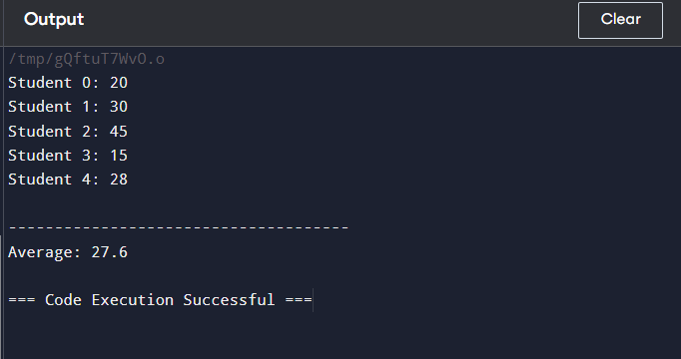

**Task 2:**

*// Write a program to input the marks of 5 students, then find and display the maximum and minimum marks*

#include <iostream>

using namespace std**;**

*int* calculateMin(*int* **marks**[]**,** *int* **size**){

*int* min **=** marks[0]**;**

**for**(*int* i**=**0**;** i**<**size**;** i**++**){

**if**(marks[i] **<** min){

            min **=** marks[i]**;**

        }

    }

**return** min**;**

}

*int* calculateMax(*int* **marks**[]**,** *int* **size**){

*int* max **=** marks[0]**;**

**for**(*int* i**=**0**;** i**<**size**;** i**++**){

**if**(marks[i] **>** max){

            max **=** marks[i]**;**

        }

    }

**return** max**;**

}

*void* getUserInput(*int* *\****marks,** *int* **size**){

**for**(*int* i**=**0**;** i**<**size**;** i**++**){

        cout**<<**"\nEnter marks of Student "**<<**i**<<**": "**;**

        cin**>>\***(marks **+** i)**;**

    }

}

*int* main() {

*int* marks[5] **=** {20**,** 30**,** 45**,** 15**,** 28}**;**

*int* size **=** **sizeof**(marks)**/sizeof**(*int*)**;**

    getUserInput(marks**,** size)**;**

    cout**<<**"\n"**;**

    cout**<<**"Max Marks: "**<<**calculateMax(marks**,** size)**<<**endl**;**

    cout**<<**"Min Marks: "**<<**calculateMin(marks**,** size)**<<**endl**;**

**return** 0**;**

}

**Output:**

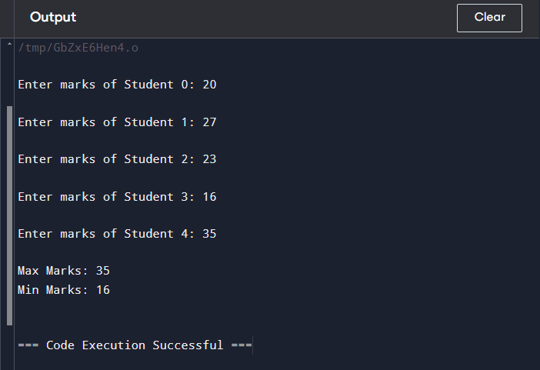

**Task 3:**

*// Write a program that inputs 5 integers into an array and then displays the elements in reverse order.*

#include <iostream>

using namespace std**;**

*void* reverseArray(*int\** **arr,** *int* **size**) {

*int***\*** start **=** arr**;** *// Pointer to the first element*

*int***\*** end **=** arr **+** size **-** 1**;** *// Pointer to the last element*

*// Swap elements while the start pointer is before or equal to the end pointer*

**while** (start **<** end) {

*// Swap the values*

*int* temp **=** **\***start**;**

**\***start **=** **\***end**;**

**\***end **=** temp**;**

*// Move the pointers*

        start**++;**

        end**--;**

    }

}

*void* getUserInput(*int* *\****marks,** *int* **size**){

**for**(*int* i**=**0**;** i**<**size**;** i**++**){

        cout**<<**"\nEnter marks of Student "**<<**i**<<**": "**;**

        cin**>>\***(marks **+** i)**;**

    }

}

*void* displayMarks(*int* *\****marks,** *int* **size**){

**for**(*int* i**=**0**;** i**<**size**;** i**++**){

        cout**<<**"Student "**<<**i**<<**": "**<<\***(marks **+** i)**<<**endl**;**

    }

}

*int* main() {

*int* marks[5] **=** {20**,** 30**,** 45**,** 15**,** 28}**;**

*int* size **=** **sizeof**(marks)**/sizeof**(*int*)**;**

    getUserInput(marks**,** size)**;**

    cout**<<**"\n"**;**

    reverseArray(marks**,** size)**;**

    displayMarks(marks**,** size)**;**

**return** 0**;**

}

**Output:**

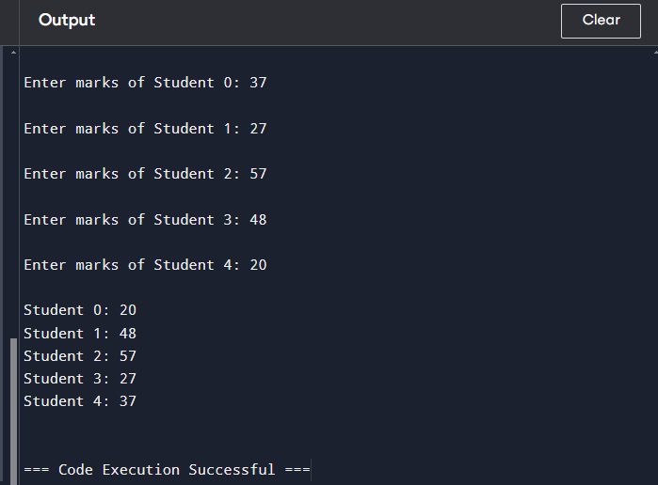

**Task 4:**

*// Write a program that inputs 10 integers into an array, then counts how many of them are even and how many are odd.*

#include <iostream>

using namespace std**;**

*void* getUserInput(*int* *\****marks,** *int* **size**){

**for**(*int* i**=**0**;** i**<**size**;** i**++**){

        cout**<<**"\nEnter num "**<<**i**<<**": "**;**

        cin**>>\***(marks **+** i)**;**

    }

}

*int* main() {

*int* nums[10]**;**

*int* size **=** 10**;**

    getUserInput(nums**,** size)**;**

    cout**<<**"\n"**;**

*int* odds **=** 0**;**

*int* evens **=** 0**;**

**for**(*int* i**=**0**;** i**<**size**;** i**++**){

**if**(nums[i]**%**2**==**0) evens**++;**

**else** odds**++;**

    }

    cout**<<**"Evens: "**<<**evens**<<**"\nOdds: "**<<**odds**;**

**return** 0**;**

}

**Output:**

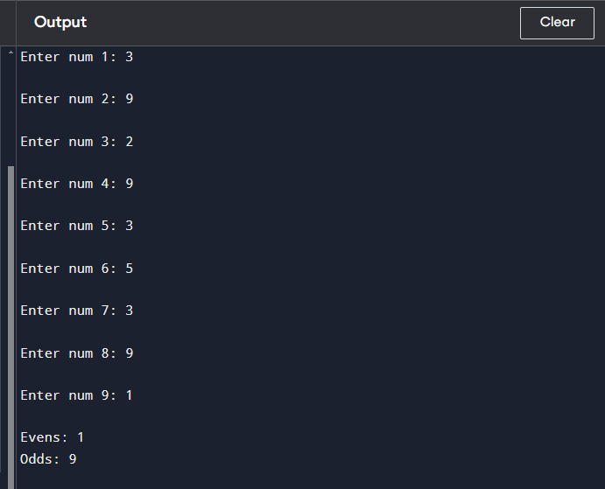

**Task 5:**

#include <iostream>

using namespace std**;**

*int* main() {

*int* numbers[10]**;**

*int* positiveSum **=** 0**,** negativeSum **=** 0**;**

*// Input 10 integers*

    cout **<<** "Enter 10 integers: " **<<** endl**;**

**for** (*int* i **=** 0**;** i **<** 10**;** i**++**) {

        cin **>>** numbers[i]**;**

    }

*// Calculate sum of positive and negative numbers*

**for** (*int* i **=** 0**;** i **<** 10**;** i**++**) {

**if** (numbers[i] **>** 0) {

            positiveSum **+=** numbers[i]**;**

        } **else** **if** (numbers[i] **<** 0) {

            negativeSum **+=** numbers[i]**;**

        }

    }

*// Output the results*

    cout **<<** "Sum of positive numbers: " **<<** positiveSum **<<** endl**;**

    cout **<<** "Sum of negative numbers: " **<<** negativeSum **<<** endl**;**

**return** 0**;**

}

**Output:**

